[**Day 9 (8th Feb'22) - Data Structures & Algorithms**](https://learnifyme.ialabs.co.in/course/view.php?id=19#section-9)

**Khushi Agrawal**

**Java batch 1**

**SESSION 1**

**LINKED LISTS:**

1. **SINGLY LINKED LIST**

A linked list is a linear data structure, in which the elements are not stored at contiguous memory locations. The elements in a linked list are linked using pointers.

It consists of nodes where each node contains a data field and a reference(link) to the next node in the list.

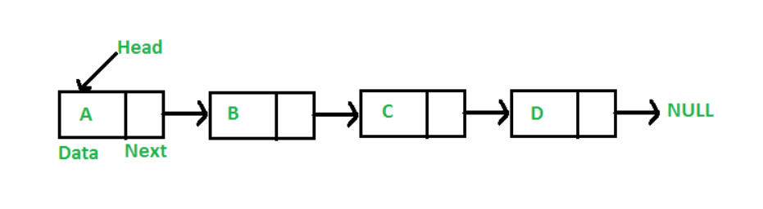

1. **DOUBLY LINKED LIST**

A **D**oubly **L**inked **L**ist contains an extra pointer, typically called *previous pointer*, together with next pointer and data which are there in singly linked list.

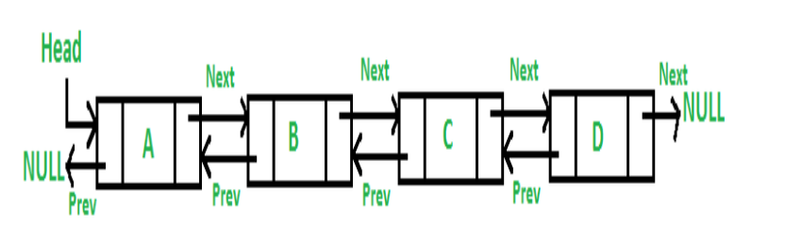

1. **CIRCULAR LINKED LIST**

***Circular linked list*** is a linked list where all nodes are connected to form a circle. There is no NULL at the end. A circular linked list can be a singly circular linked list or doubly circular linked list.

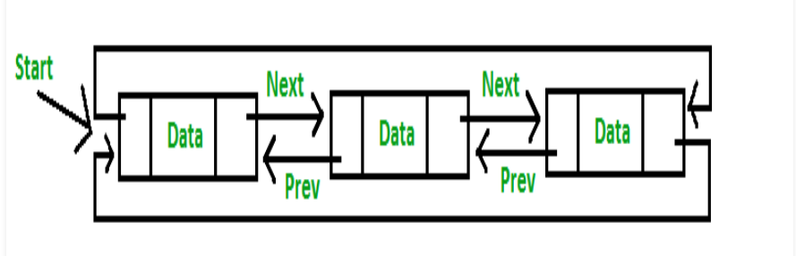

**4.STACK**

Stack is a linear data structure which follows a particular order in which the operations are performed. The order may be LIFO(Last In First Out) or FILO(First In Last Out).

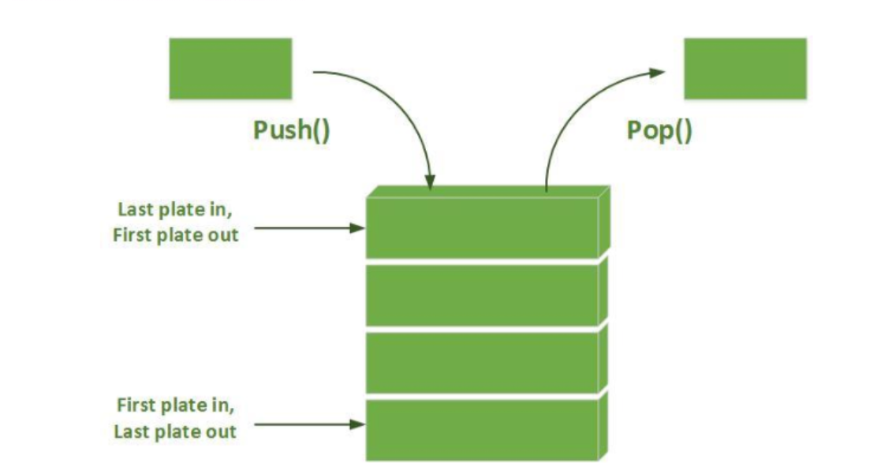

**5.QUEUE**

A Queue is a linear structure which follows a particular order in which the operations are performed. The order is First In First Out (FIFO).

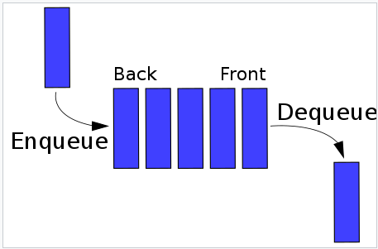

**SESSION 2**

**6 .Take array of list apply linear search.**

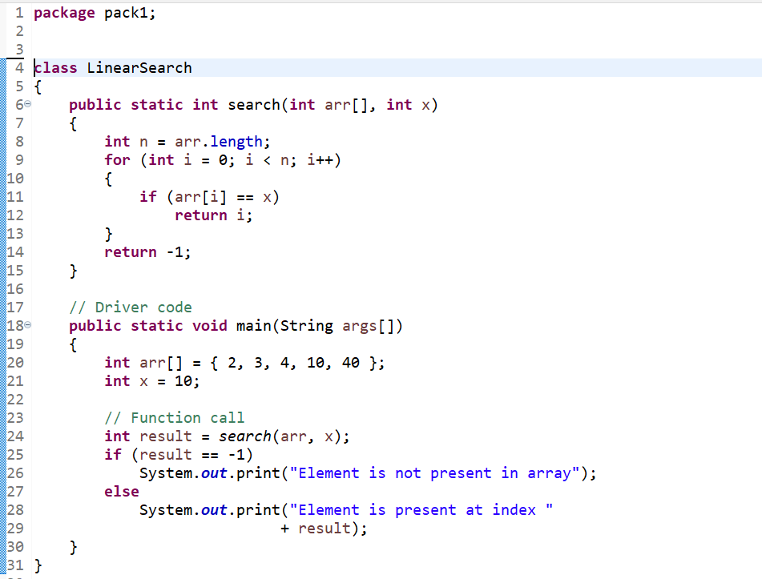

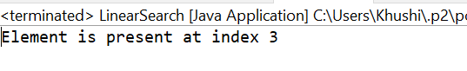

**7.** **Take a sorted array and apply binary search**

